Intermediate Algebra Lecture 7.7: Introducing and Simplifying Complex Fractions

Complex Fractions - fractions within fractions

Steps
- Simplify so main numerator and main denominator have only one fraction
- Set up a division problem
- Simplify

Example
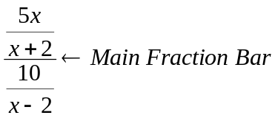

Example
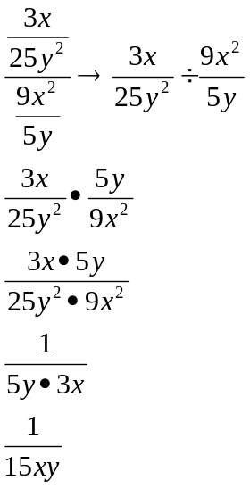

Example
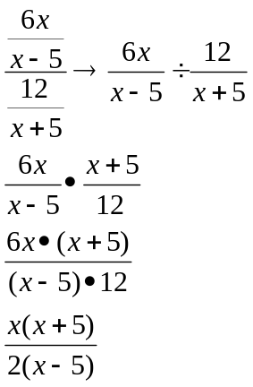

Example
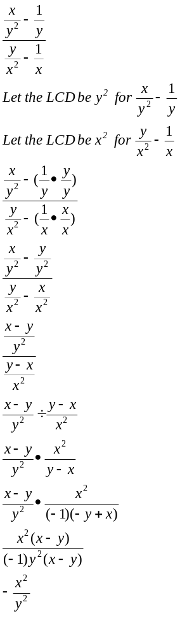

Example
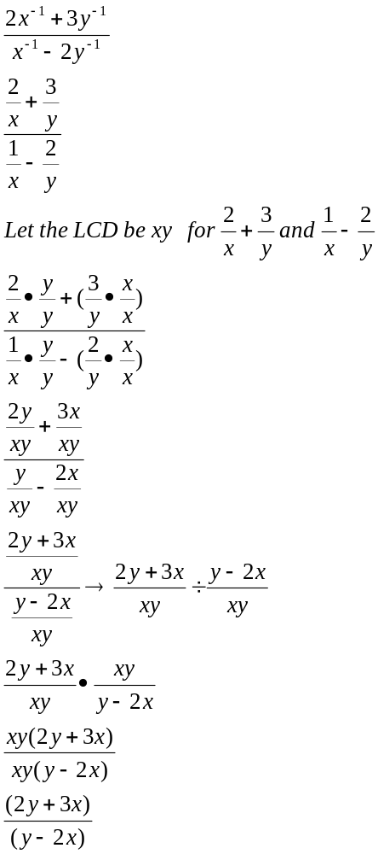

Example
